NETWORK FUNDAMENTALS

A network is simply a group of two or more Personal Computers linked together.

Computer Network Types
A computer network is a group of computers linked to each other that enables the computer to communicate with another computer and share their resources, data, and applications.
A computer network can be categorized by their size. A computer network is mainly of four types:
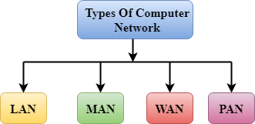
- LAN (Local Area Network)
- PAN (Personal Area Network)
- MAN (Metropolitan Area Network)
- WAN (Wide Area Network)

LAN (Local Area Network)
- Local Area Network is a group of computers connected to each other in a small area such as building, office.
- LAN is used for connecting two or more personal computers through a communication medium such as twisted pair, coaxial cable, etc.
- It is less costly as it is built with inexpensive hardware such as hubs, network adapters, and ethernet cables.
- The data is transferred at an extremely faster rate in Local Area Network.
- Local Area Network provides higher security.
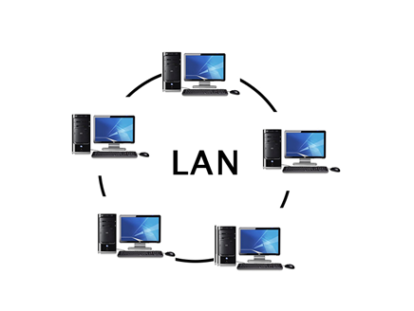

PAN (Personal Area Network)
- Personal Area Network is a network arranged within an individual person, typically within a range of 10 meters.
- Personal Area Network is used for connecting the computer devices of personal use is known as Personal Area Network.
- Thomas Zimmerman was the first research scientist to bring the idea of the Personal Area Network.
- Personal Area Network covers an area of 30 feet.
- Personal computer devices that are used to develop the personal area network are the laptop, mobile phones, media player and play stations.
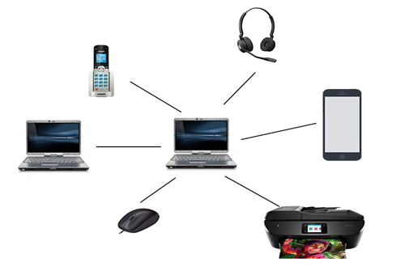
There are two types of Personal Area Network:
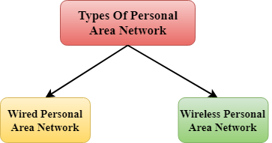
- Wired Personal Area Network
- Wireless Personal Area Network
Wireless Personal Area Network: Wireless Personal Area Network is developed by simply using wireless technologies such as WiFi, Bluetooth. It is a low range network.
Wired Personal Area Network: Wired Personal Area Network is created by using the USB.

Examples of Personal Area Network:
- Body Area Network: Body Area Network is a network that moves with a person. For example, a mobile network moves with a person. Suppose a person establishes a network connection and then creates a connection with another device to share the information.
- Offline Network: An offline network can be created inside the home, so it is also known as a home network. A home network is designed to integrate the devices such as printers, computer, television but they are not connected to the internet.
- Small Home Office: It is used to connect a variety of devices to the internet and to a corporate network using a VPN

MAN (Metropolitan Area Network)
- A metropolitan area network is a network that covers a larger geographic area by interconnecting a different LAN to form a larger network.
- Government agencies use MAN to connect to the citizens and private industries.
- In MAN, various LANs are connected to each other through a telephone exchange line.
- The most widely used protocols in MAN are RS-232, Frame Relay, ATM, ISDN, OC-3, ADSL, etc.
- It has a higher range than Local Area Network(LAN).
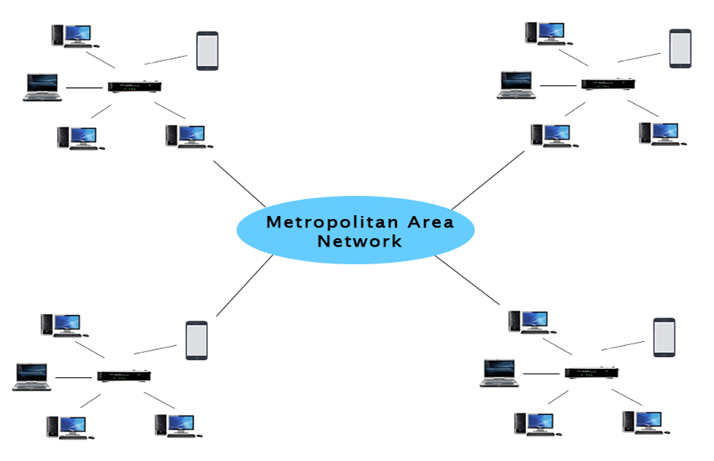

Uses of Metropolitan Area Network:
- MAN is used in communication between the banks in a city.
- It can be used in an Airline Reservation.
- It can be used in a college within a city.
- It can also be used for communication in the military.

WAN (Wide Area Network)
- A Wide Area Network is a network that extends over a large geographical area such as states or countries.
- A Wide Area Network is quite bigger network than the LAN.
- A Wide Area Network is not limited to a single location, but it spans over a large geographical area through a telephone line, fibre optic cable or satellite links.
- The internet is one of the biggest WAN in the world.
- A Wide Area Network is widely used in the field of Business, government, and education.
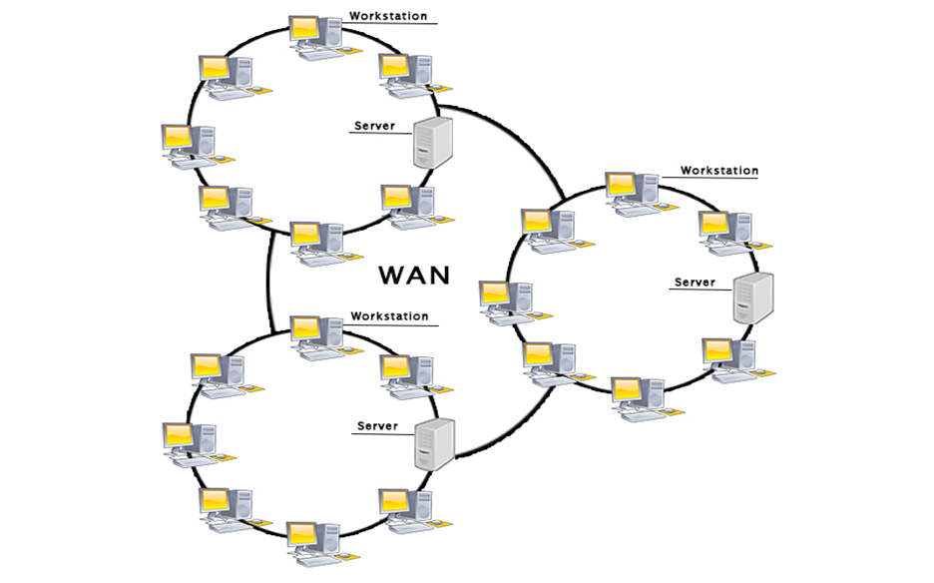

Examples of Wide Area Network:
- Mobile Broadband: A 4G network is widely used across a region or country.
- Last mile: A telecom company is used to provide the internet services to the customers in hundreds of cities by connecting their home with fiber.
- Private network: A bank provides a private network that connects the 44 offices. This network is made by using the telephone leased line provided by the telecom company.

Advantages of Wide Area Network:
Following are the advantages of the Wide Area Network:
- Geographical area: A Wide Area Network provides a large geographical area. Suppose if the branch of our office is in a different city then we can connect with them through WAN. The internet provides a leased line through which we can connect with another branch.
- Centralized data: In case of WAN network, data is centralized. Therefore, we do not need to buy the emails, files or back up servers.
- Get updated files: Software companies work on the live server. Therefore, the programmers get the updated files within seconds.
- Exchange messages: In a WAN network, messages are transmitted fast. The web application like Facebook, Whatsapp, Skype allows you to communicate with friends.
- Sharing of software and resources: In WAN network, we can share the software and other resources like a hard drive, RAM.
- Global business: We can do the business over the internet globally.
- High bandwidth: If we use the leased lines for our company then this gives the high bandwidth. The high bandwidth increases the data transfer rate which in turn increases the productivity of our company.

Disadvantages of Wide Area Network:
The following are the disadvantages of the Wide Area Network:
- Security issue: A WAN network has more security issues as compared to LAN and MAN network as all the technologies are combined together that creates the security problem.
- Needs Firewall & antivirus software: The data is transferred on the internet which can be changed or hacked by the hackers, so the firewall needs to be used. Some people can inject the virus in our system so antivirus is needed to protect from such a virus.
- High Setup cost: An installation cost of the WAN network is high as it involves the purchasing of routers, switches.
- Troubleshooting problems: It covers a large area so fixing the problem is difficult.

Other types of networks

Wireless Local Area Network (WLAN)
Functioning like a LAN, WLANs make use of wireless network technology, such as Wi-Fi. Typically seen in the same types of applications as LANs, these types of networks don’t require that devices rely on physical cables to connect to the network.

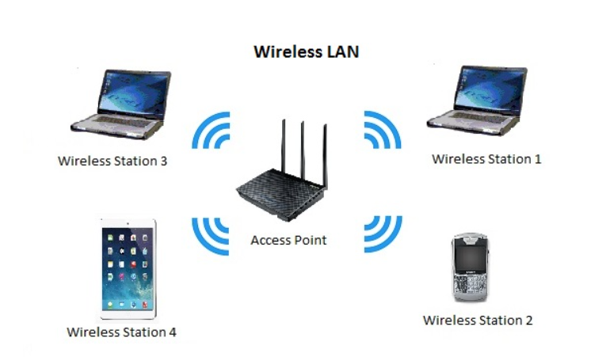

4. Campus Area Network (CAN)
Larger than LANs, but smaller than metropolitan area networks (MANs, explained below), these types of networks are typically seen in universities, large school or small businesses. They can be spread across several buildings that are fairly close to each other so users can share resources.
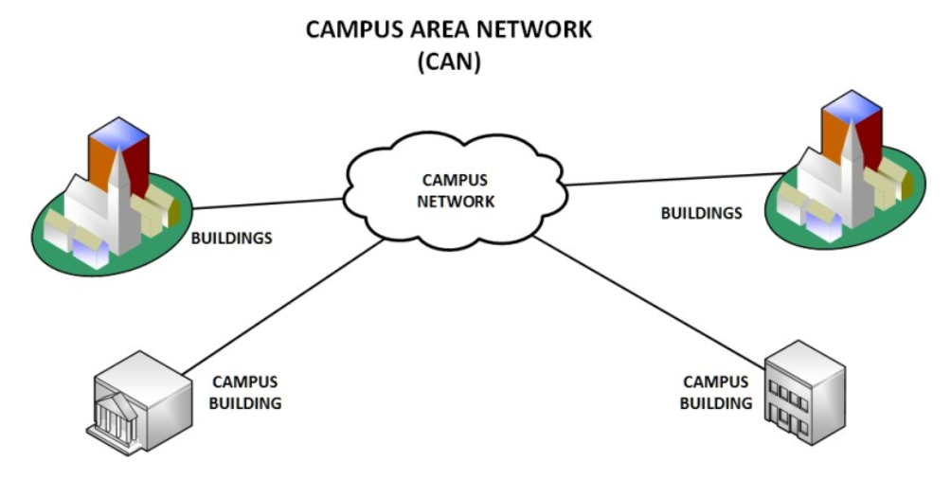

Storage-Area Network (SAN)
As a dedicated high-speed network that connects shared pools of storage devices to several servers, these types of networks don’t rely on a LAN or WAN. Instead, they move storage resources away from the network and place them into their own high-performance network. SANs can be accessed in the same fashion as a drive attached to a server. Types of storage-area networks include converged, virtual and unified SANs.
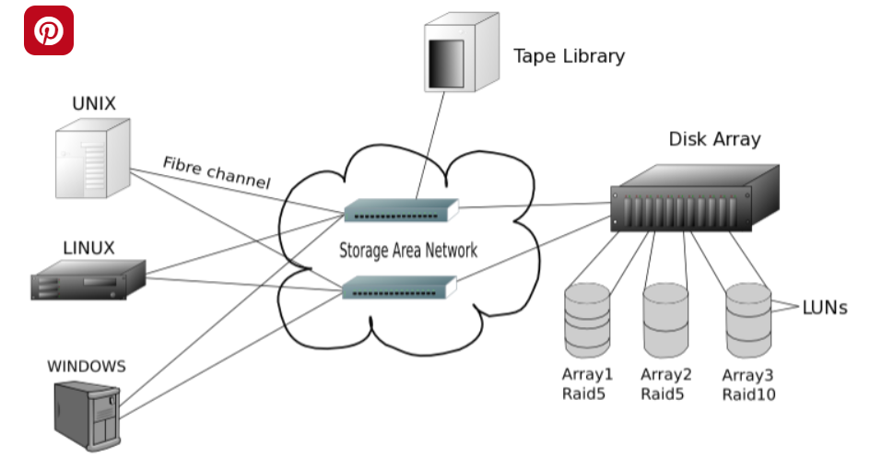

Enterprise Private Network (EPN)
These types of networks are built and owned by businesses that want to securely connect its various locations to share computer resources.
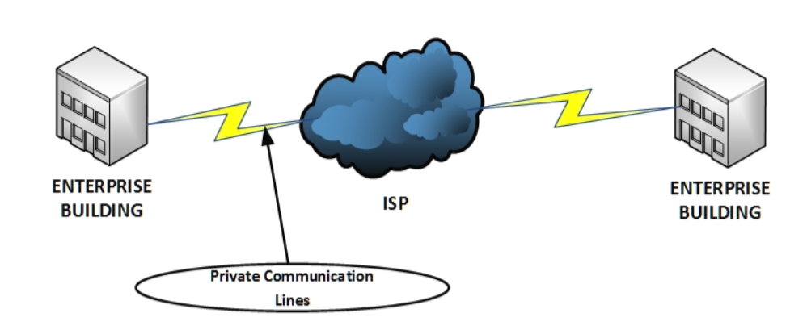

Virtual Private Network (VPN)
By extending a private network across the Internet, a VPN lets its users send and receive data as if their devices were connected to the private network – even if they’re not. Through a virtual point-to-point connection, users can access a private network remotely.
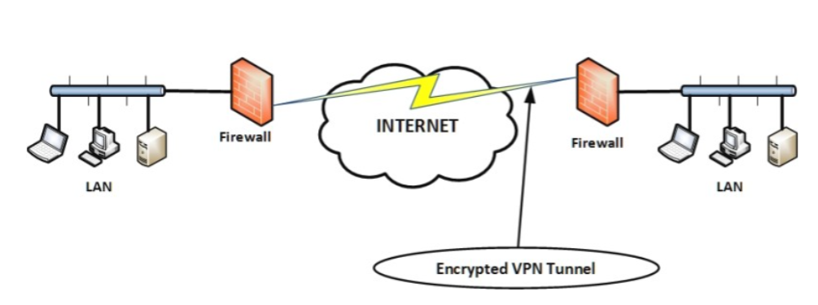

Internetwork
- An internetwork is defined as two or more computer network LANs or WAN or computer network segments are connected using devices, and they are configured by a local addressing scheme. This process is known as internetworking.
- An interconnection between public, private, commercial, industrial, or government computer networks can also be defined as internetworking.
- An internetworking uses the internet protocol.
- The reference model used for internetworking is Open System Interconnection(OSI).

Types Of Internetwork:
1. Extranet: An extranet is a communication network based on the internet protocol such as Transmission Control protocol and internet protocol. It is used for information sharing. The access to the extranet is restricted to only those users who have login credentials. An extranet is the lowest level of internetworking. It can be categorized as MAN, WAN or other computer networks. An extranet cannot have a single LAN, atleast it must have one connection to the external network.
2. Intranet: An intranet is a private network based on the internet protocol such as Transmission Control protocol and internet protocol. An intranet belongs to an organization which is only accessible by the organization's employee or members. The main aim of the intranet is to share the information and resources among the organization employees. An intranet provides the facility to work in groups and for teleconferences.

Intranet advantages:
- Communication: It provides a cheap and easy communication. An employee of the organization can communicate with another employee through email, chat.
- Time-saving: Information on the intranet is shared in real time, so it is time-saving.
- Collaboration: Collaboration is one of the most important advantage of the intranet. The information is distributed among the employees of the organization and can only be accessed by the authorized user.
- Platform independency: It is a neutral architecture as the computer can be connected to another device with different architecture.
- Cost effective: People can see the data and documents by using the browser and distributes the duplicate copies over the intranet. This leads to a reduction in the cost.

Network Topologies
Network topology refers to how various nodes, devices, and connections on your network are physically or logically arranged in relation to each other. Think of your network as a city, and the topology as the road map. Just as there are many ways to arrange and maintain a city such as, making sure the avenues and boulevards can facilitate passage between the parts of town getting the most traffic. There are several ways to arrange a network. Each has advantages and disadvantages and depending on the needs of your company, certain arrangements can give you a greater degree of connectivity and security.
There are two approaches to network topology:
- Physical
- Logical.
Physical network topology, as the name suggests, refers to the physical connections and interconnections between nodes and the network, the wires, cables, and so forth.
Logical network topology is a little more abstract and strategic, referring to the conceptual understanding of how and why the network is arranged the way it is, and how data moves through it.

Why Is Network Topology Important?
The layout of your network is important for several reasons. Above all, it plays an essential role in how and how well your network functions. Choosing the right topology for your company’s operational model can increase performance while making it easier to locate faults, troubleshoot errors, and more effectively allocate resources across the network to ensure optimal network health. A streamlined and properly managed network topology can increase energy and data efficiency, which can in turn help to reduce operational and maintenance costs.
The design and structure of a network are usually shown and manipulated in a software-created network topology diagram. These diagrams are essential for a few reasons, but especially for how they can provide visual representations of both physical and logical layouts, allowing administrators to see the connections between devices when troubleshooting.
The way a network is arranged can make or break network functionality, connectivity, and protection from downtime. The question of, “What is network topology?” can be answered with an explanation of the two categories in the network topology.
- Physical – The physical network topology refers to the actual connections (wires, cables, etc.) of how the network is arranged. Setup, maintenance, and provisioning tasks require insight into the physical network.
- Logical – The logical network topology is a higher-level idea of how the network is set up, including which nodes connect to each other and in which ways, as well as how data is transmitted through the network. Logical network topology includes any virtual and cloud resources.
Effective network management and monitoring require a strong grasp of both the physical and logical topology of a network to ensure your network is efficient and healthy.

Types of Topology

There are five types of topology in computer networks:
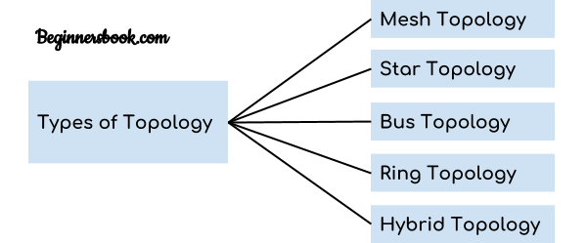
1. Mesh Topology
2. Star Topology
3. Bus Topology
4. Ring Topology
5. Hybrid Topology

Mesh Topology
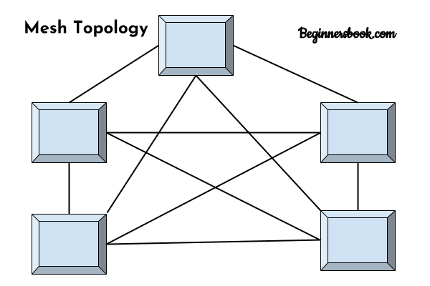
In mesh topology each device is connected to every other device on the network through a dedicated point-to-point link. When we say dedicated it means that the link only carries data for the two connected devices only. Lets say we have n devices in the network then each device must be connected with (n-1) devices of the network. Number of links in a mesh topology of n devices would be n(n-1)/2.

Advantages of Mesh topology
1. No data traffic issues as there is a dedicated link between two devices which means the link is only available for those two devices.
2. Mesh topology is reliable and robust as failure of one link doesn’t affect other links and the communication between other devices on the network.
3. Mesh topology is secure because there is a point to point link thus unauthorized access is not possible.
4. Fault detection is easy.

Disadvantages of Mesh topology
1. Amount of wires required to connected each system is tedious and headache.
2. Since each device needs to be connected with other devices, number of I/O ports required must be huge.
3. Scalability issues because a device cannot be connected with large number of devices with a dedicated point to point link.

Star Topology
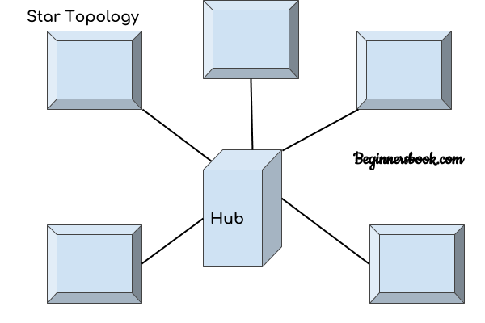
In star topology each device in the network is connected to a central device called hub. Unlike Mesh topology, star topology doesn’t allow direct communication between devices, a device must have to communicate through hub. If one device wants to send data to other device, it has to first send the data to hub and then the hub transmit that data to the designated device.

Advantages of Star topology
1. Less expensive because each device only need one I/O port and needs to be connected with hub with one link.
2. Easier to install
3. Less amount of cables required because each device needs to be connected with the hub only.
4. Robust, if one link fails, other links will work just fine.
5. Easy fault detection because the link can be easily identified.

Disadvantages of Star topology
1. If hub goes down everything goes down, none of the devices can work without hub.
2. Hub requires more resources and regular maintenance because it is the central system of star topology.

Bus Topology
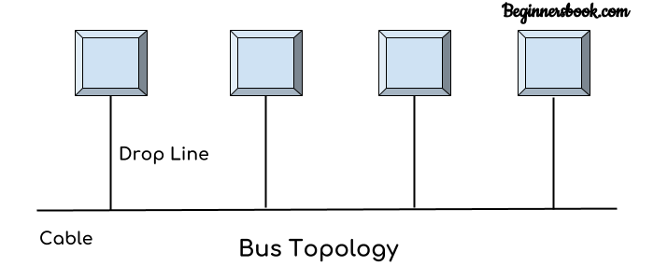
In bus topology there is a main cable and all the devices are connected to this main cable through drop lines. There is a device called tap that connects the drop line to the main cable. Since all the data is transmitted over the main cable, there is a limit of drop lines and the distance a main cable can have.

Advantages of bus topology
1. Easy installation, each cable needs to be connected with backbone cable.
2. Less cables required than Mesh and star topology

Disadvantages of bus topology
1. Difficultly in fault detection.
2. Not scalable as there is a limit of how many nodes you can connect with backbone cable.

Ring Topology
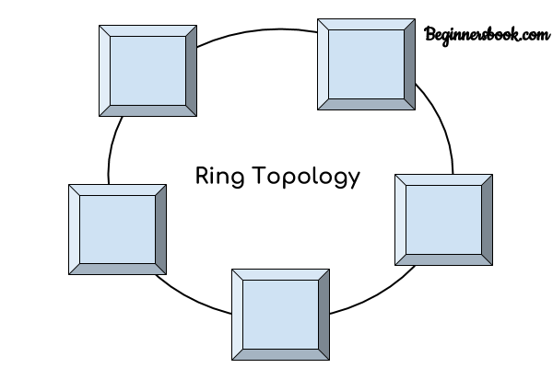
In ring topology each device is connected with the two devices on either side of it. There are two dedicated point to point links a device has with the devices on the either side of it. This structure forms a ring thus it is known as ring topology. If a device wants to send data to another device then it sends the data in one direction, each device in ring topology has a repeater, if the received data is intended for other device then repeater forwards this data until the intended device receives it.

Advantages of Ring Topology
1. Easy to install.
2. Managing is easier as to add or remove a device from the topology only two links are required to be changed.

Disadvantages of Ring Topology
1. A link failure can fail the entire network as the signal will not travel forward due to failure.
2. Data traffic issues, since all the data is circulating in a ring.

Hybrid topology
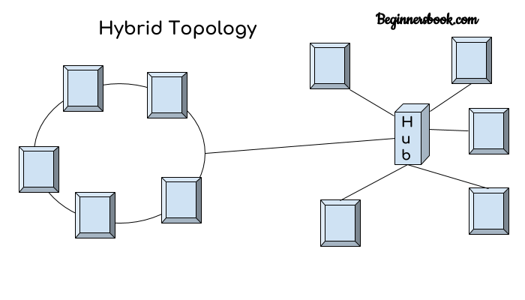
A combination of two or more topology is known as hybrid topology. For example a combination of star and mesh topology is known as hybrid topology.

Advantages of Hybrid topology
1. We can choose the topology based on the requirement for example, scalability is our concern then we can use star topology instead of bus technology.
2. Scalable as we can further connect other computer networks with the existing networks with different topologies.

Disadvantages of Hybrid topology
1. Fault detection is difficult.
2. Installation is difficult.
3. Design is complex so maintenance is high thus expensive.

